
GALGOTIAS UNIVERSITY
Plot No.2, Sector -17 A, Yamuna Expressway,
Greater Noida, Gautam Buddha Nagar, U.P., India

SCHOOL OF COMPUTING SCIENCE & ENGINEERING

“LAB PRACTICAL FILE”

Course Name: TECHNICAL TRAINING-I
Course Code: BCSE2390

School: SCSE

Program: B. Tech
Year: 2nd Semester: 3
Session: 2021-2022

Submitted By: | Submitted To:
NEERAJ SINGH  21SCSE1011675  SEC-6- P1 | Ravi Sharma SIR

List of Programs
1-) Write a program for swapping of two numbers
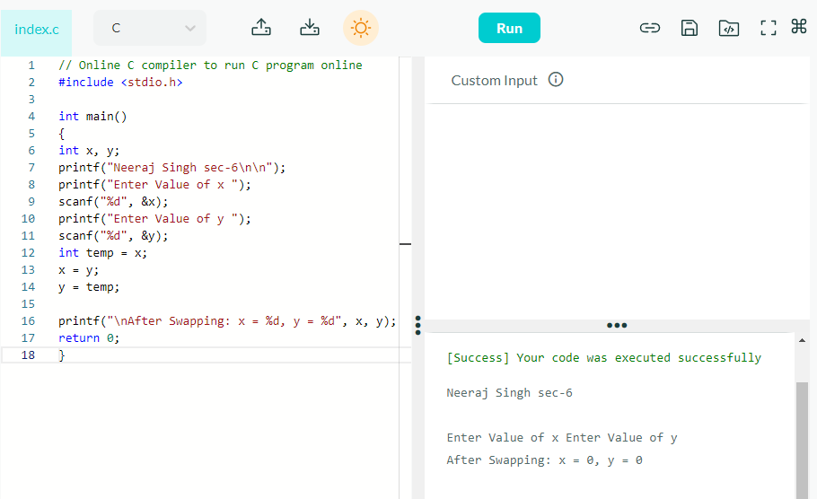
2-) Write a program for Factorial number
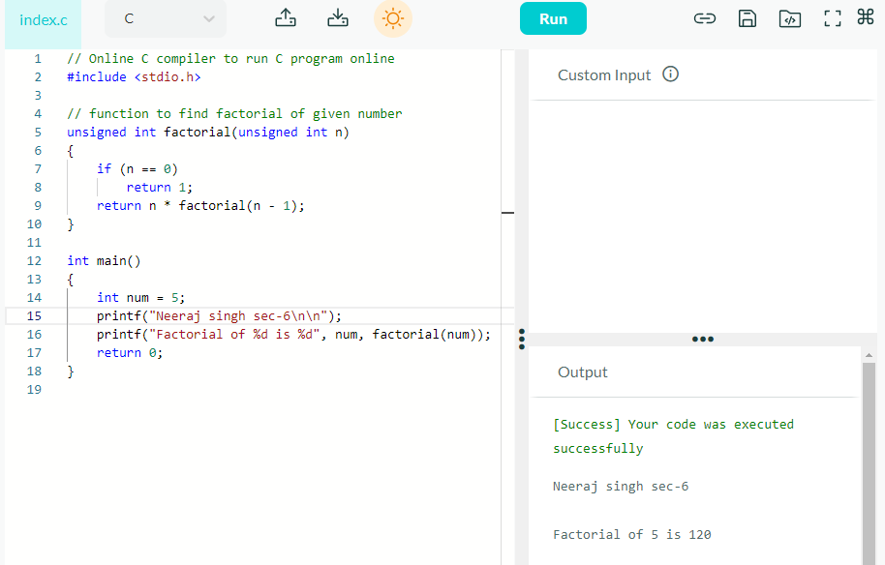

3-)Write a program for on switch-case, if-else and loop statements
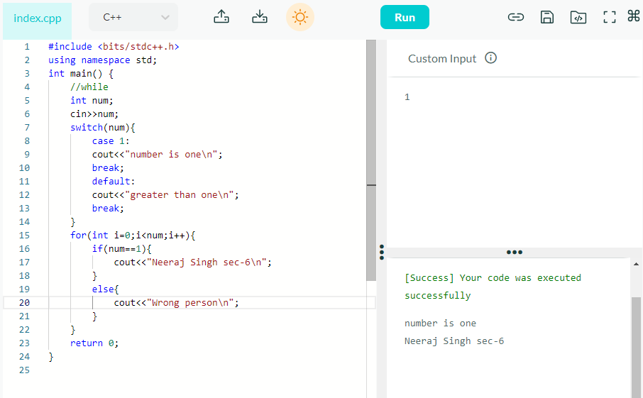
4-)Write a program for nested for/while loop for printing pattern.
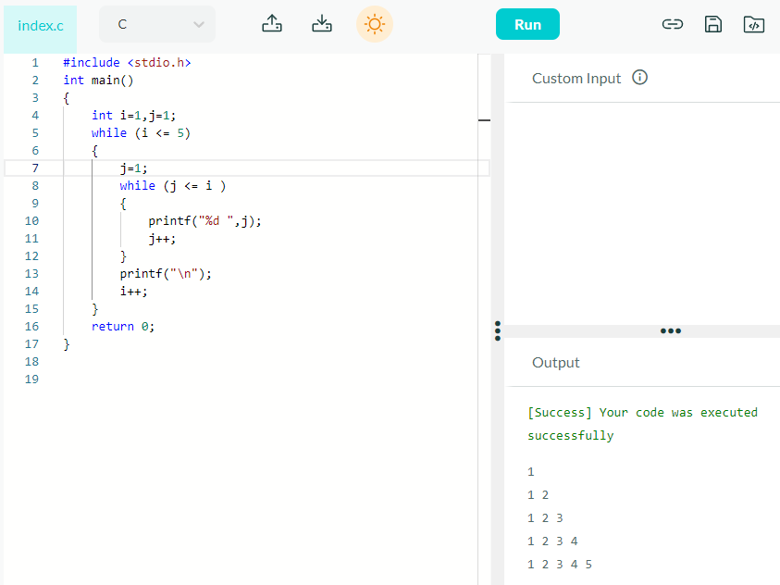
- Write a program for sum of diagonal elements
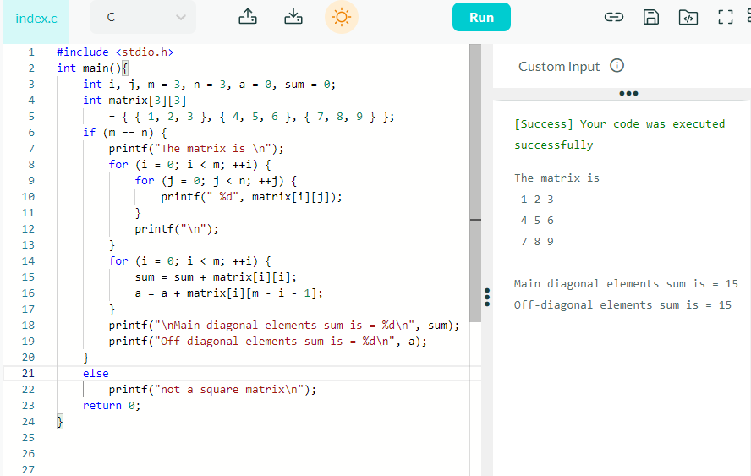
- Write a program for sum of all the outside elements of a 2-D arrays.
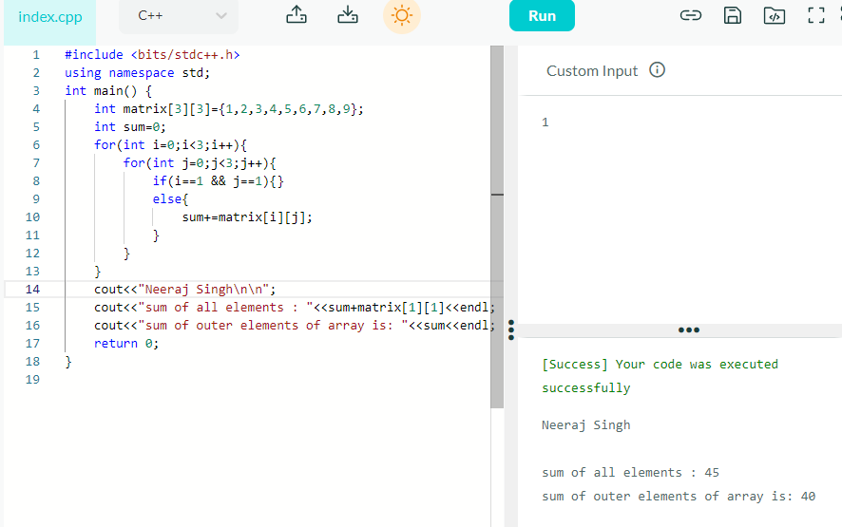
- Write a program for based on sorting using recursive and non-recursive calls of function having pointer and arrays as an argument.
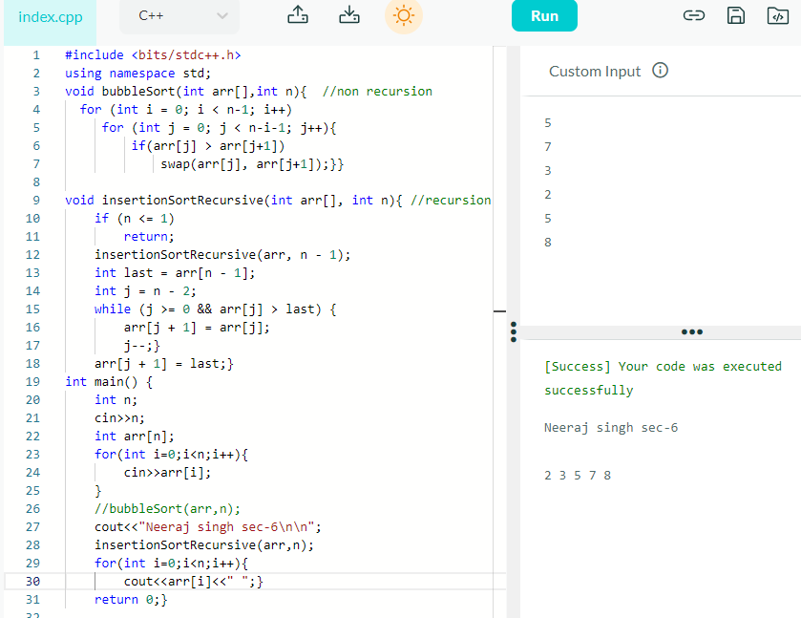
- Problem based upon nested/ self-referential structure.
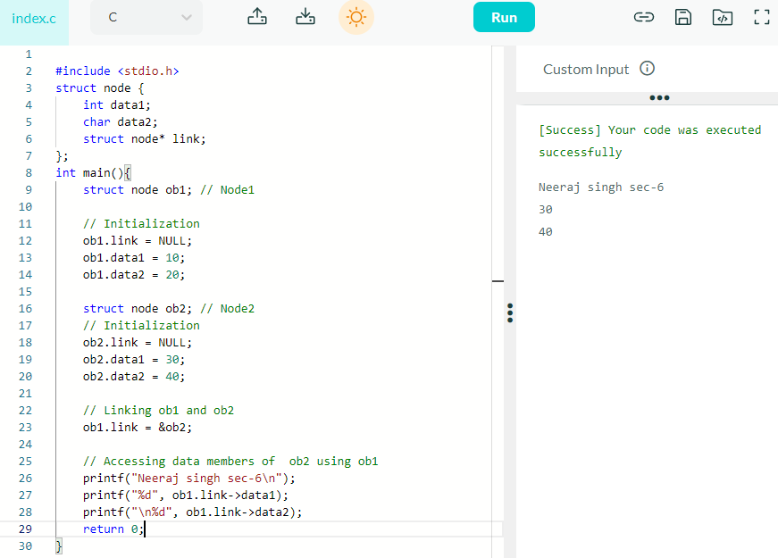
- Problem based upon Union, passing it as an argument inside the function

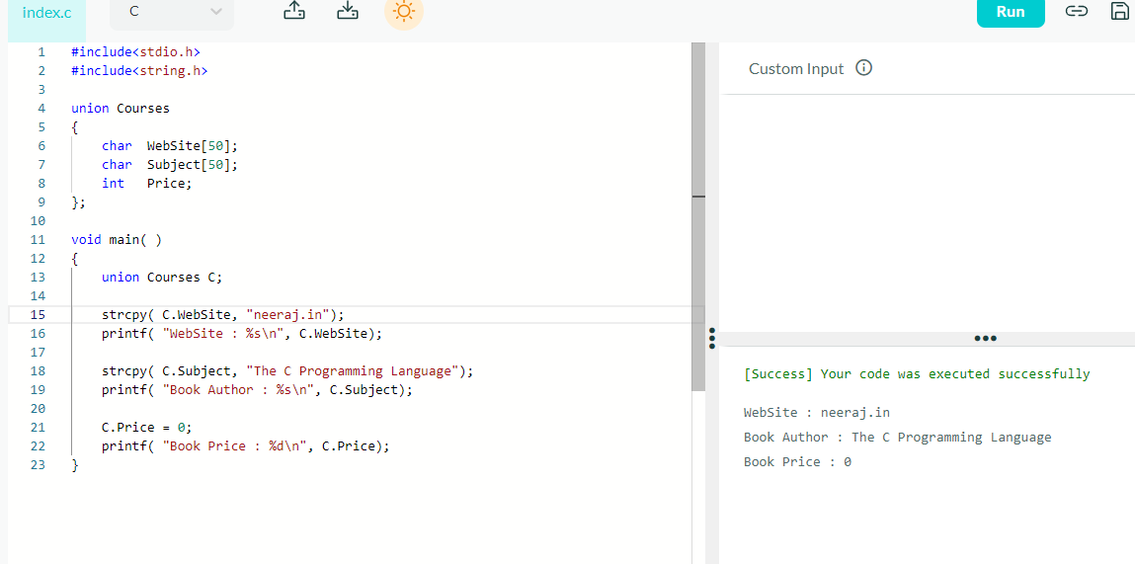

- Revision -Problem based upon classes and objects

